**Manual of the game**

**«CLOSE CONTACT»**

version 1.0



Created by: ***RedCode Team***

**Menu**

**History for game** ------------------------------------------------- 3

**Main functionality** ----------------------------------------------- 4

**About authors** ---------------------------------------------------- 5

**History**

It was the 3457 year, a few centuries ago the Earth lost after a nuclear war...

We are the last survivors flew away from Earth in the hope of finding a new planet on which we begin to live again...

But as nobody counted on such a long journey, we have almost no resources and no I'm not talking about the food and water (despite the fact that synthetics are not really the taste is still possible to eat), I'm talking about fuel.

The only way his production is down in the past the flying asteroids in the hope that they have fuel.

Despite the fact that this asteroid is sufficient flow of resources (not enough for all engines but can move forward), we have a problem with aliens. They do not agree upon the world and almost ran out of ammo.

I hope this is not my last entry 01.11.3457

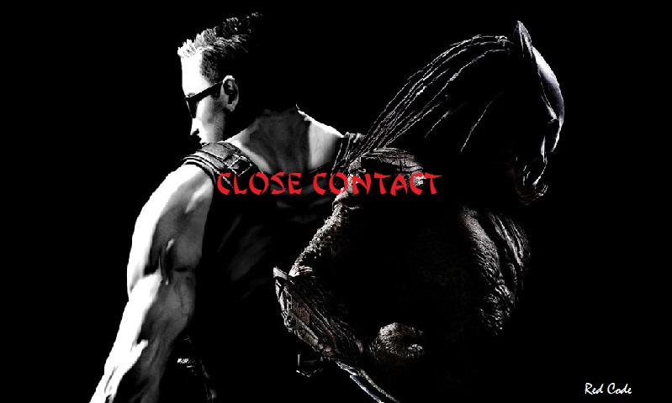

**Main functionality**

**Rocket**

Rocket in our game is the base object which have store and upgrade function. For activate rocket, click by it and choose upgrade mine for speed up resources creation or buy soldier for 500 resource value. When rocket is ready for fly, game is ending and redirects to the main menu.

In future we want to create saving record, you can see this in code part.

Also you can seen, that rocket change color.

**Battle**

Battle is the main view activity part of our game. On it, you see your army and UFO’s soldier, which go to our rocket. Also you can see button with clock. This button removes some percent(1-20) of rocket upgrade.

When units dead, it change color to red and then disappeared from screen.

**Soldiers&UFO**

Each of them has three different classes. They differ by health points, damage, power, etc and they have animation effects.

C:\Users\COMP\AppData\Roaming\Skype\alena22091971\media_messaging\media_cache_v3\^241554A22FD8803BBAB0AFEBE761325C0C77A18A59A5A9ADD9^pimgpsh_fullsize_distr.png

C:\Users\COMP\AppData\Roaming\Skype\alena22091971\media_messaging\media_cache_v3\^522CB02A43DC8E51CB755354EC2406DF4933A25352AD57A024^pimgpsh_fullsize_distr.png

**About us**

**Kyrylengo Georgiy**

Second year study student at VNTU on CS faculty,. Visualization and testing.

**Dmytro Kudriavtsev**

Second year study student at VNTU on CS faculty,. Logic and sound creation.

**Vlad Tytchev**

Forth year study student at VNTU on CS faculty.Designer

**Andrey Andreev**

Forth year study student at VNTU on CS faculty.Designer

**